**Established under the Presidency University Act, 2013 of the Karnataka Act 41 of 2013**

**School of Engineering**

**DEPARTMENT OF COMPUTER SCIENCE AND ENGINEERING**

**Course code:** CSE220-IOT LAB

**IOT PROJECT**

Fire Alarm System

TeamMembers

|  |  |  |
| --- | --- | --- |
| SL no. | ID Number | Name |
| 1 | 20191IST0002 | Aditi |
| 2 | 20191IST0010 | Aniket Mohapatra |
| 3 | 20191IST0198 | Saya Vamshi Krishna |

Fire Alarm System

Instructor Signature

**Lakshmisha S K**

**Abstract**

This paper presents a comprehensive review of fire alarm systems. Fire Alarm System are particularly important devices to detect fire in the right time and prevent any damage to people or property Fire Alarm Circuits and Smoke Sensors are a part of the security systems which help in detecting or preventing damage. Installing Fire Alarm Systems and Smoke Sensors in commercial buildings like offices, movie theatres, shopping malls and other public places demandingly compulsory. We present a simple and low-cost fire alarm systems there are simple components used of a fire alarm system are discussed in detail. The components discussed include smoke Sensor, Arduino uno,LM-35Temperature Sensor, Breadboard, and Piezo Buzzer. And finally, the paper concludes with a discussion of the importance of proper installation and maintenance of fire alarm systems.

**Introduction**

A fire alarm system has several devices working together to detect and warn people through visual and audio appliances when smoke, fire, carbon monoxide or other emergencies are present. These alarms may be activated automatically from Smoke detectors, and heat detectors may also be activated via manual fire alarm activation devices such as manual call points or pull stations.

Alarms can be either motorized bells or wall mountable sounders or horns. They can also be speaker strobes which sound an alarm, followed by a voice evacuation message which warns people inside the building not to use the elevators. Fire alarm sounders can be set to certain frequencies and different tones including low, medium, and high, depending on the country and manufacturer of the device.

Most fire alarm systems in Europe sound like a siren with alternating frequencies. Fire alarm electronic devices are known as horns in the United States and Canada and can be either continuous or set to different codes. Fire alarm warning devices can also be set to different volume levels. Manually actuated devices; also known as fire alarm boxes, manual pull stations, or simply pull stations, break glass stations, and (in Europe) call points. Devices for manual fire alarm activation are installed to be readily located (near the exits), identified, and operated.

They are usually actuated by means of physical interaction, such as pulling a lever or breaking glass. Automatically actuated devices can take many forms intended to respond to any number of detectable physical changes associated with fire: convicted thermal energy; heat detector, products of combustion; smoke detector, radiant energy; flame detector, combustion gases; firegas detector, and release of extinguishing agents; water-flow detector. The newest innovations can use cameras and computer algorithms to analyse the visible effects of fire and movement in applications inappropriate for or hostile to other detection methods.

**Principle**

The fire alarm working principle is based on thermistor used in the fire alarm circuit. This fire alarm circuit is used to identify and indicate an increase in temperature beyond certain value (temperature of an enclosed area). All Fire Alarm Systems operate on the same principle. If a detector detects smoke or heat, or someone operates a break glass unit, then alarm sounders operate to warn others in the building that there may be a fire and evacuate thermistor is an inexpensive and easily obtainable temperature sensitive resistor, thermistor working principle is its resistance depends upon the temperature. When temperature changes, the resistance of the thermistor changes in a predictable way. The benefits of using a thermistor are accuracy and stability.

**Hardware Required**

* Arduino UNO board

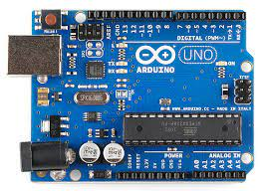

Arduino board is a microcontroller that is used to accept inputs from sensors connected and provide an output action on the desired device connected to it. The sensor inputs can be from light-detecting sensors, motion sensors (Ultrasonic or IR), temperature sensors, etc. The output from this device can be received through other output devices such as LED, Buzzer, Serial monitor, etc.

* LM-35 Temperature Sensor

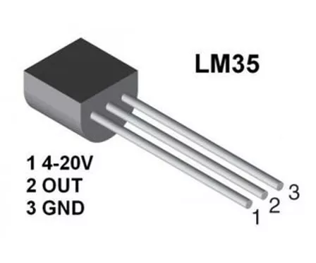

LM-35 Temperature Sensor gives an analog output based on the instantaneous temperature value. This analog output is proportional to the instantaneous input.

* Gas Sensor

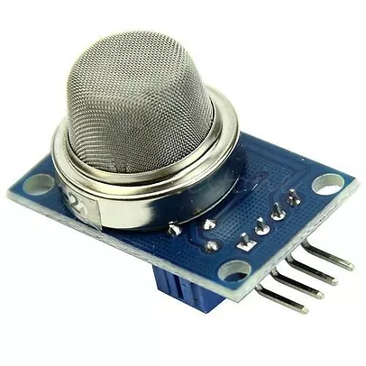

The gas sensor is used to measure the concentration or presence of gas in the atmosphere. It is also used to detect smoke in the air. Based on the gas, a potential difference is generated by changing the resistance of the material present inside the sensor. The output is measure in terms of Voltage.

* Resistors

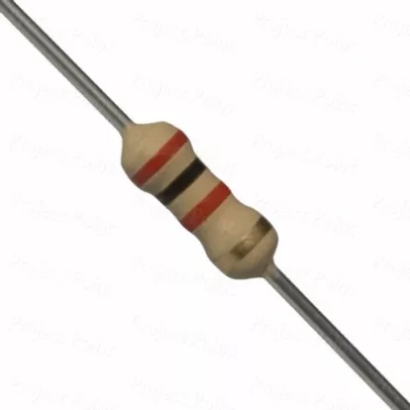

Resistors are passive devices that restrict the flow of current or divide the voltage through the circuit. The input power passes through these resistors and then to the sensors to avoid damage.

* Breadboard

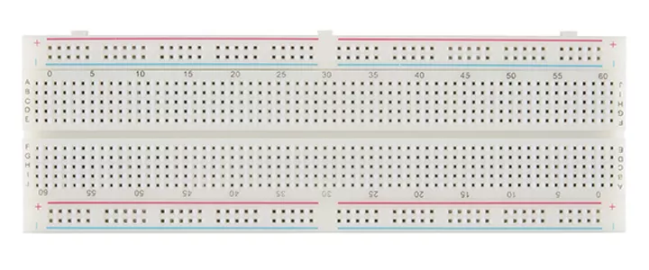

The breadboard is the basic component of any circuit building process. All components, be it input sensors or output display devices are connected to the power supply, microcontroller using wired connections through a breadboard. The holes in the breadboard are in series. There are many sizes like full-sized, half-sized, and mini breadboard.

* Piezo Buzzer

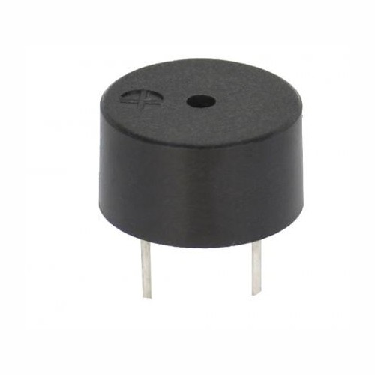

It is an electrical component that generates a beep sound on receiving an input. It works on the principle of piezo crystal.

* Jumper Wires

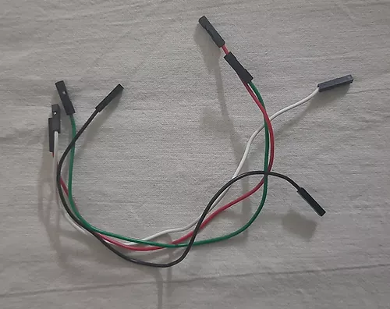

These are the main components that are used to establish the connections between different devices of the circuit.

Software Requirement

TinkerCad circuit simulation software.

Auridon

Circuit Connections

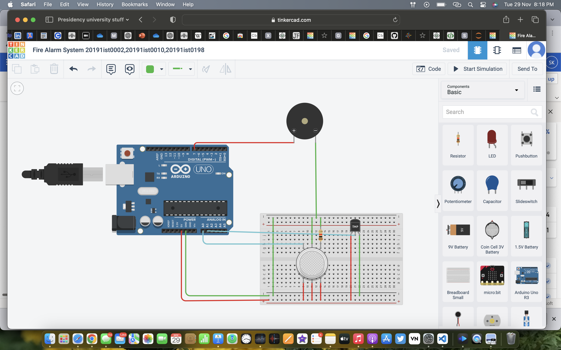

The circuit connections are as follows.

Firstly, we need to connect one line of the breadboard to the ground and the other to the power supply. This is done by connecting the 5V pin of the Arduino Board to one line of connection pins on the breadboard. The other line of the breadboard is connected to the ground terminal of the Arduino Board. These lines will be connected to other devices.

The Temperature sensor has three pins. Ground, Vout, and Vs (Supply). The Vs pin that has a range of 4-20V is connected to the power supply line of the breadboard. The Ground terminal of the sensor is connected to the ground line of the breadboard. The Vout terminal of the temperature sensor is connected to one of the Analog pins of the Arduino Board, A1.

Now let us learn how the connections are done with the Gas sensor. This sensor has 6 pins. 3 pins of the gas sensor are directly connected to the power supply line of the breadboard. Amongst the other 3 pins of the sensor, one pin is connected to one of the Analog pins of the Arduino Board, A0. The pin in the middle is connected to the ground line of the breadboard. The third pin of the sensor is connected to a resistor and then connected to the ground line.

Lastly, the piezo buzzer is externally connected to the circuit. The ground pin of the buzzer is connected to the ground line of the breadboard. Another pin of the buzzer is connected to the digital pin, PIN 7 of the Arduino Board.

Working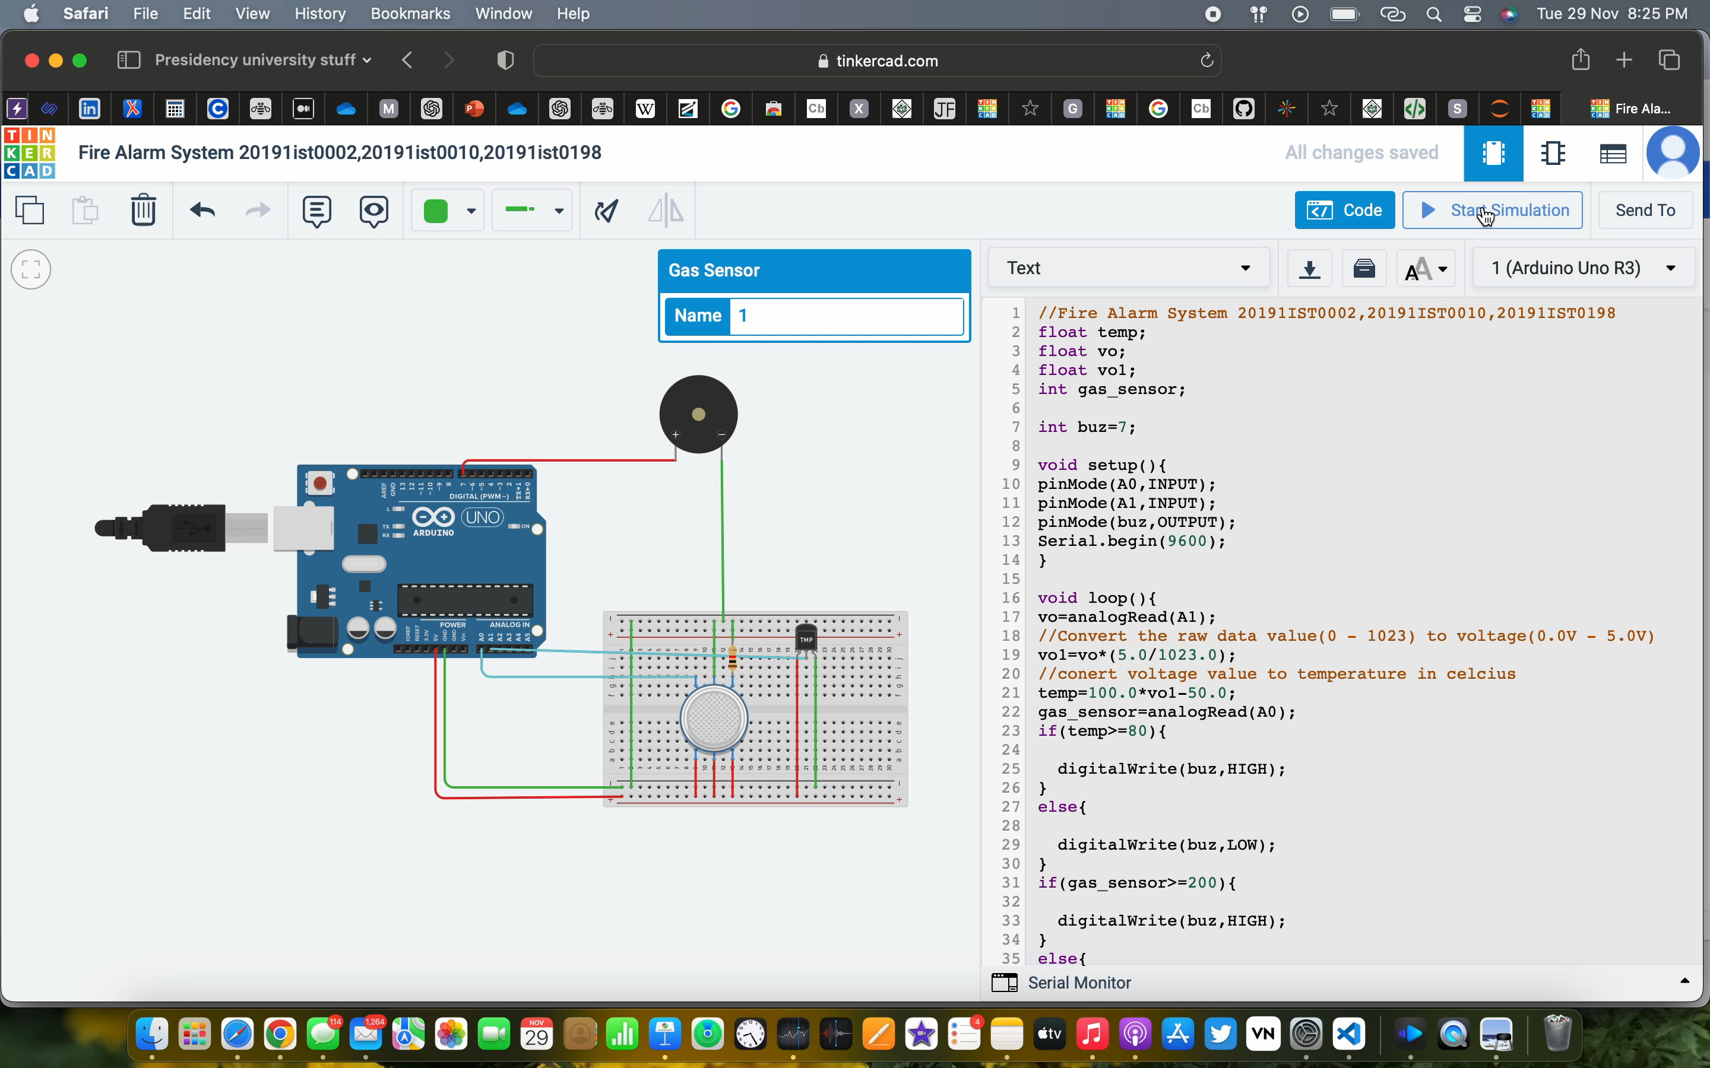

Working of the circuit, we can understand it in two parts.

Part 1: Temperature sensor and its output.

The Temperature sensor takes in input and when the temperature increases, the voltage increases, and hence the output initiates the functioning of the Buzzer. For every one degree increase in temperature, there is a 10mV increase in the voltage.

Part2: Gas sensor and its output.

A gas sensor is also used to detect smoke along with the concentration of gases. Based on the type of gas present in the atmosphere, a potential difference is developed by changing the Resistance of the material present inside the sensor and the same is measured as output.

**Code:**

/Fire Alarm System 20191IST0002,20191IST0010,20191IST0198

float temp;

float vo;

float vo1;

int gas_sensor;

int buz=7;

void setup(){

pinMode(A0,INPUT);

pinMode(A1,INPUT);

pinMode(buz,OUTPUT);

Serial.begin(9600);

}

void loop(){

vo=analogRead(A1);

//Convert the raw data value(0 - 1023) to voltage(0.0V - 5.0V)

vo1=vo*(5.0/1023.0);

//conert voltage value to temperature in celcius

temp=100.0*vo1-50.0;

gas_sensor=analogRead(A0);

if(temp>=80){

digitalWrite(buz,HIGH);

}

else{

digitalWrite(buz,LOW);

}

if(gas_sensor>=200){

digitalWrite(buz,HIGH);

}

else{

digitalWrite(buz,LOW);

}

Serial.print("temperature in C =");

Serial.print(" ");

Serial.print(temp);

Serial.print(" ");

Serial.print("Gas Sensor =");

Serial.print(" ");

Serial.print(gas_sensor);

Serial.println();

delay(500);

}

|  |  |
| --- | --- |
| **Advantages** | **Disadvantages** |
| * Detection Distance * Sensitivity * Speed of Response * Reliability | * Narrow field of vision * Expensive * Difficult of Maintain |

**CONCLUSION**

Thus, we conclude from this fire alarm is used for safety and emergency purpose. This is not only use in houses but also in any type of buildings

**Demonstration**

**SEE ALSO:**

* [Controlling Home Appliances using Arduino and HC-05 Bluetooth module.](https://www.learnelectronicsindia.com/post/controlling-home-appliances-using-arduino-and-hc-05-bluetooth-module)
* [Interfacing Water/Rain sensor with Arduino.](https://www.learnelectronicsindia.com/post/interfacing-water-rain-sensor-with-arduino)
* [IoT based Fire Alarm System using Raspberry pi.](https://www.learnelectronicsindia.com/post/iot-based-fire-alarm-system-using-raspberry-pi)

Demonstration

